**Indian Institute of Technology Bombay**

**DEPARTMENT OF METALLURGICAL ENGINEERING & MATERIALS SCIENCE**

**MM 204 Transport Phenomena : 2019-20 : Spring**

**Tutorial 1 Jan 17, 2020; 0830h**

1. In the three situations shown find the pressure at A or the pressure difference between A and B, as the case may be.

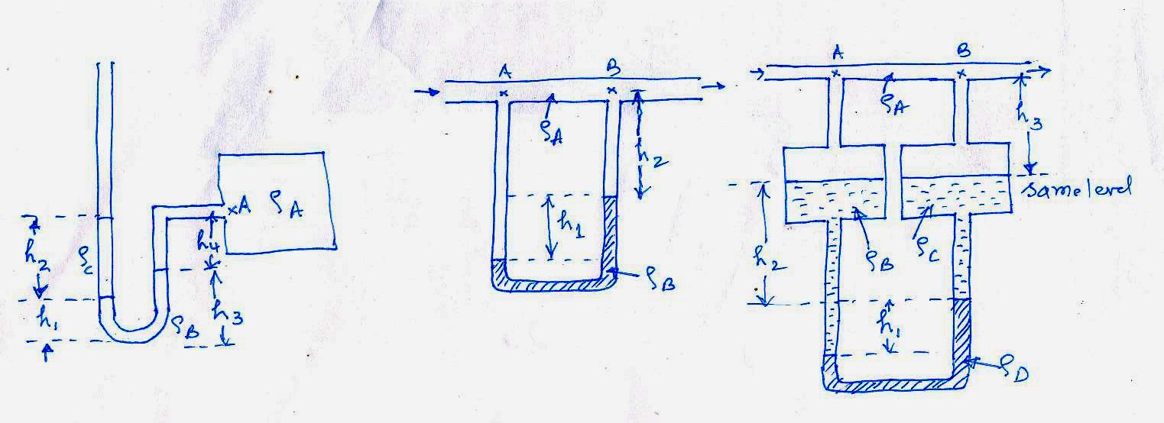

air

(a) (b) (c)

1. 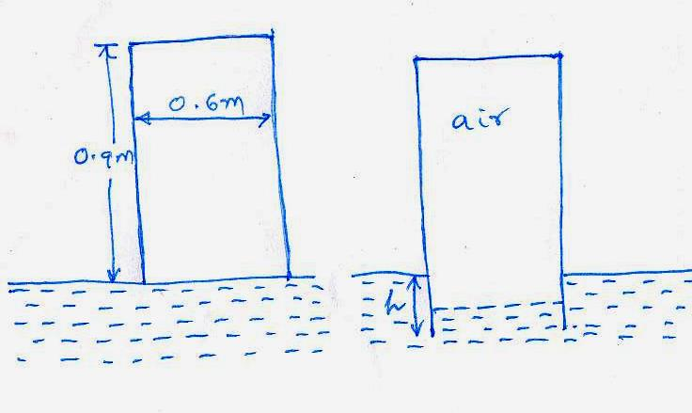An open cylindrical tank shown in the figure weighing 100kg is allowed to progressively submerge in water as shown. To what depth h will the tank submerge when it becomes stationary? The local barometer pressure is 1.013x105 Pa. The thickness of the tank may be neglected. What additional force is required to bring the top of the tank flush with the water surface ? (WWWR)
2. A dam spillway gate holds back water of depth *h*. The gate is symmetrical about the pivot and weighs 400 kg/m and is hinged at A. At what minimum depth of water will the gate remain locked and prevent water from overflowing ? (Take moments about the pivot A).